**WORKING WITH DATASET**

**DATA PREPARATION**

|  |  |
| --- | --- |
| Date | 07 November 2022 |
| Team ID | PNT2022TMID43705 |
| Project Name | Project – AIRLINES DATA ANALYTICS FOR AVAITION INDUSTRY |
| Maximum Marks | 2 Marks |

**Fields (The Global Airport Database dataset):**

**Name Type**

|  |  |
| --- | --- |
| ICAO Code | (3-4 chars, A - Z) |
| IATA Code | (3 chars, A - Z) |
| Airport Name | String |
| City/Town | String |
| Country | String |
| Latitude Degrees | Integer [0,360] |
| Latitude Minutes | Integer [0,60] |
| Latitude Seconds | Integer [0,60] |
| Latitude Direction | Char (N or S) |
| Longitude Degrees | Integer [0,360] |
| Longitude Minutes | Integer [0,60] |

**Example**

KATL

ATL

THE WILLIAM B HARTSFIELD ATLANTA INTERNATIONAL

ATLANTA

USA

33

38

25

N

84

25

|  |  |  |
| --- | --- | --- |
| **Name** | **Type** | **Example** |
| Longitude Seconds | Integer [0,60] | 37 |
| Longitude Direction | Char (E or W) | W |
| Altitude (Altitude in meters from mean sea level) | Integer [-  99999,+99999] | 313 |
| Latitude Decimal Degrees | Floating point [-  90,90] | 33.64 |
| Longitude Decimal Degrees | Floating point [-  180,180] | -84.427 |

**Fields Preview (Main Dataset):**

Set 1: 15/27 columns

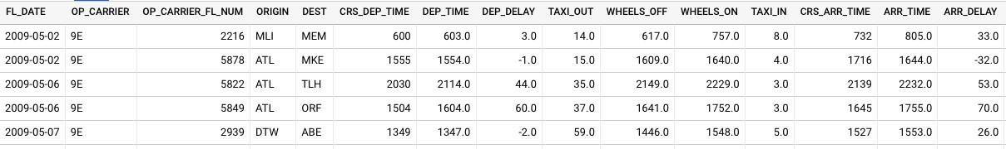

Set 2: Remaining 12/27 columns

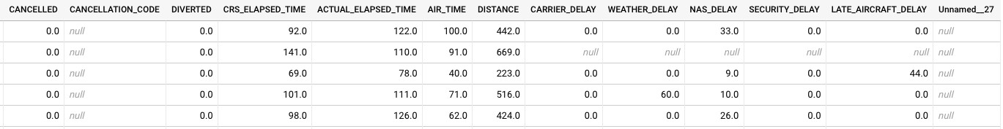

Fields Preview (Auxillary Dataset):

